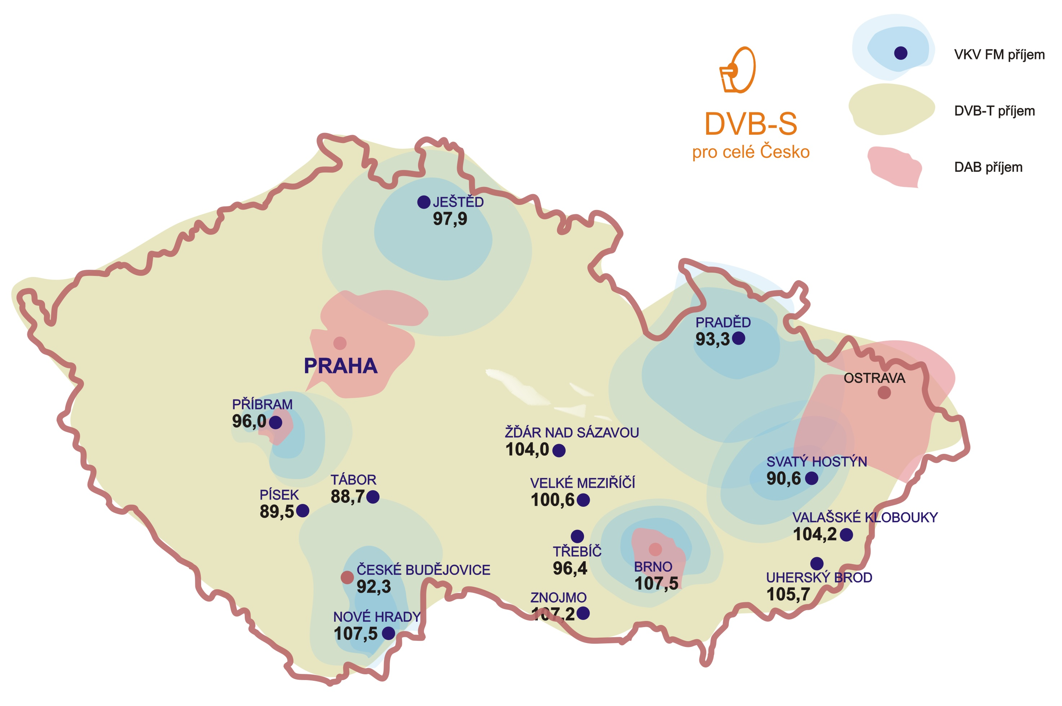
Address:
Radio Proglas, Barvičova 85, CZ - 602 00 Brno
Tel.: +420 543 217 241, Fax: +420 543 217 245
GSM gate: +420 603 170 692
E-mail: radio@proglas.cz
Homepage: www.proglas.cz

Basic facts on Radio Proglas

Licence bestowed by
The Council: Broadcast from December 8, 1995. For the time of next 6 years, till June 7, 2015.
Keeper of the Licence: Radio Proglas Ltd., non-commercial broadcast company. Company is the member of CERC (Conférence Européenne des Radios Chrétiennes) at European Council; www.cerc-eu.eu
Characterisation of broadcasting: For informative cultural family based upon traditional Christian virtue. The aim is also a support of democracy in the state.
Broadcasting: Beginning: December 8, 1995 – Svatý Hostýn 90.6 MHz, 500 W, next: Brno 107.5 MHz, 2.88 kW • Praděd 93.3 MHz, 20 kW • Ještěd 97.9 MHz,
20 kW, Příbram-Drahlín 96.0 MHz, 126 W • Uherský Brod 105,7 MHz, 200 W • Nové Hrady – Dobrá Voda 107.5 MHz, 2 kW • České Budějovice
92.3 MHz, 500 W • Tábor 88.7 MHz, 1 kW, Písek 89.5 MHz, 500 W, Velké Meziříčí 100.6 MHz, 200 W, Žďár nad Sázavou 104.0 MHz, 200 W,
Třebíč 96,4 MHz, Znojmo 107,2 MHz, Třebíč 96,4 MHz, Valašské Klobouky 104,2 MHz. All of them have RDS. The DVB-T system throughout the country. The DAB system for Prague, Příbram, Brno a Ostravsko.
Satellite distribution and transmitting: (DVB-S) ASTRA 3A, MPEG-2, 23.5 degrees east, V-pol.; 12,525 GHz; 27.5 MSps; FEC 3/4; PID: 180
Daytime of broadcasting: non-stop
Location: Back part of the building of Bishop’s high school, address: Radio Proglas, Barvičova 85, CZ-602 00 Brno, Czech Republic;
250 sq m – studios, 400 sq m – editors’ office.
Other regional studios: Prague (Kristián), Olomouc (Radim), Ostrava (Hedvika), Hradec Kralove (Vojtěch), Litomerice (Stepan), Ceske Budejovice (Jan Neumann).
Workers: 40 altogether, co-operatives (voluntary): permanently 40, casually next 200.
Director: P. Martin Holik, Chief editor: Pavel Miksu, manager: Helena Horakova, dramaturge: Marie Blazkova.
Support of broadcasting: The Friends Club Of Radio Proglas: 22 250 members, i.e. 64 000 persons, addition 60 members a month. Next 16 500 contributory non-
-members.
Donated amount: 26,000,000 CZK per year, i. e. about 1 000 CZK per member (amount voluntary, rule: 1,50 CZK per day and a member = 2 persons)
Target group of listeners: Broadcasting is set for all age categories, for all the people of good will without the difference of belief (at least 10 Christian churches participate in broadcasting). Rate of spoken word – music: spoken word 45 %, music 55 %.
Market Research: (Media Projekt of the firm Stem/Mark – Taylor Nelson Sofres – STEM/MARK II.–III. Q. 2011): Listeners the last 7 days 100,000; the most listened to station 40,000. A half of our listeners live in the towns with about 5000 citizens.
Rate of types of programs: prayers 6.3 %, news 9.4 %, for children and youth 4.1 %, culture 7.5 %, education 8.7 %, classical and spiritual music 14.9 %, popular music 43.5 %, folklore 5.6 %
Making of programs: 94 % of our own, besides Czech Radio news, then 5 hours a week TWR, 3 hours a week Radio Vaticana. Repeats altogether about 5 %.
Interesting: Set of programs for children: Fairy Tale, Broadcasting Little Town, Barvínek, Proglaso. Poetry. Reading of books. Classical music. Broadcasting for mothers. For Seniors. Music: As you like it, Music-Top-Twelve Kolem se toc, etc.
Contact with listeners: outside broadcasting:3 times a year bulletin of which once a year Magazin »Vlnění« (50,000), once a year pilgrimage (1,000 persons in the day of world prayers for media), once a year »Visiting Day« (300–500 visitors). Internet. Personal visits. Distrib. of bulletins: 1100 co-operatives (»KaPr«), technical help (»Sumec«), letters: 16,000 a year.
in programs: ‘Vzkazy’, Music-Top-Twelve, ‘Proglaso’, ‘Magdazín’, Midnight line, Congratulations, ‘Listarna’, ‘Barvinek’, etc. ‘Green line’ – free of charge.
What next: Into offering of CATV (nowadays in about 500,000 connections). Efforts to broadcasting in the DAB system throughout the Republic.

